Cairo University

Faculty of Computers and Artificial Intelligence





|  |  |
| --- | --- |
| Names | IDs |
| Shady Mohamed | 20200246 |
| Fatma Omar | 20201133 |
| Hassan Ashraf | 20200151 |
| Mohamed Abdelkader | 20190459 |
| Esraa Saeed | 20200074 |
| Hussein alumni | 20200157 |

Under supervision:

Dr./ Elham Shawky

Table of Contents

Chapter 1: Introduction..............................................................................................................................3

1.1 Project Idea.............................................................................................................................3

1.2 Project Objective.....................................................................................................................3

1.3 Project Scope and limitations..................................................................................................4

1.4 Methodology: Agile ................................................................................................................4

1.5 Related Work ..........................................................................................................................5

Chapter 2: System Centered Analysis........................................................................................................8

2.1 Functional requirements.........................................................................................................8

2.2 Non-functional requirements………………………………………………………………………………………….…11

2.3 Technology …………………………………………………………………………………………………………………….…12

2.4 System application………………………….………………………………………………………………………………..14

List of Figures

Figure 1: Agile Life Cycle ............................................................................................................................6

Figure 2: Introduction Page…………………………………………………………………………………………………………………..14

Figure 3: Welcome Page…………………………………………………………………………………………………………………….….14

Figure 4: Start Page……………………………………………………………………………………………………………………………….14

Figure 5: Login Page………………………………………………………………………………………………………………………………14

Figure 6: verification Page……………………………………………………………………………………………………………………..14

Figure 7: Home Page……………………………………………………………………………………………………………………………..14

1. Chapter 1: Introduction
   1. Project Idea:

In response to the challenges faced by job seekers within a large community, the Dot Job platform aims to provide comprehensive support and solutions to address their questions and concerns related to job applications. The platform focuses on facilitating seamless communication, sharing valuable insights, and enhancing the overall job-seeking experience.

Users can easily search for specific job opportunities based on their preferences and qualifications. The platform allows users to submit job applications directly through the application. Job seekers can create posts to share their experiences, ask questions, or seek advice from the community. Users can react to and comment on posts, fostering a collaborative and supportive environment. Employers and organizations can make announcements regarding job fairs, recruitment events, or other relevant updates. Users receive notifications for new job opportunities and important announcements.

The job seeker will be able to obtain all services from our application wherever the platform is used, after a while we will have a large amount of data that provides a lot of useful information It enables us to know the number of job categories, the number of job seekers applying for a particular job, etc. this it makes it easier for us to help them in the future.

* 1. Project objective

1. Basic objectives

* + - Developing a multi-platform application that provides employment services to job seekers.
    - Building a community that benefits from our platform and connecting them.
    - Empowering service providers to be more accessible.
    - Enabling job seekers to find suitable job opportunities for them and register for these opportunities online.
    - Enabling job seekers to build a professional CV.

2. Secondary objectives

* + - * Try to respond to job seekers about their progress in tracking the job opportunities they have applied for as quickly as possible.
      * Obtaining a huge amount of data about job categories to analyze it and knowing the number of job seekers registered in the course, and the number of contacts between the two job seekers and Employer, etc.
  1. Project scope and limitations

In this project, we will provide a multi-platform mobile application to help business owners appoint people capable of carrying out work tasks and create a brochure to describe the work in detail, attaching the form to apply for the job, as well as the requirements that must be met by the job applicant to increase the chances of being accepted for this job and help. Job seekers can apply for various job opportunities that match the data in his CV via the Internet, see the numerous publications submitted by employers, send notifications about them, verify the extent to which the job opportunity he is applying for has reached advanced levels, and work on building his own CV. And see the dashboard that enables him to analyze and detail the opportunities he applies to. All these services see a beneficial community. It can make their lives easier.

Limitation: We will work on a project which is a feature of giant platforms, so competition is quite far. Chatting will not be included in our app so no user behavior (history) data to depend on it in our recommendation. So, we need to choose the best alternative way regarding UX to communication.

* 1. Methodology: Agile

We will use agile methodology as our project life cycle because Agile methodologies, such as Scrum or Kanban, are known for their flexibility and adaptability. In a dynamic project environment, where requirements may evolve or new insights emerge, Agile allows for seamless adjustments to accommodate changes. Agile methodologies aim to deliver a minimum viable product (MVP) quickly. This enables stakeholders to start using and providing feedback on the system sooner, reducing time-to-market and allowing for quicker responses to changing market conditions. Agile practices, such as continuous testing and frequent integration, help in identifying and addressing issues early in the development process. This proactive approach contributes to risk mitigation and better overall project quality.

صورة تحتوي على نص, لقطة شاشة, دائرة, شعار

تم إنشاء الوصف تلقائياً

Figure 1: Agile Life Cycle

* 1. Related Work:

**LinkedIn:**

LinkedIn is a professional networking platform that also serves as a job search and recruitment platform. Users can create profiles, connect with professionals, and explore job opportunities.

**Indeed:**

Indeed, is a comprehensive job search engine that aggregates job listings from various sources. Users can search for jobs based on keywords, location, and other criteria.

**Glassdoor:**

Glassdoor not only lists job openings but also provides company reviews, salary information, and insights into company culture. It aims to help job seekers make informed decisions.

**Monster:**

Monster is a global job search website that connects employers with job seekers. It offers a wide range of job listings and provides tools for resume creation and career advice.

**CareerBuilder:**

CareerBuilder is an online job portal that offers job search, company research, and career advice. It covers a diverse range of industries and job types.

**SimplyHired:**

SimplyHired is a job search engine that aggregates job listings from various sources. It provides filters for location, job type, and company.

**ZipRecruiter:**

ZipRecruiter is a platform that connects employers and job seekers. It uses AI-driven matching technology to match candidates with relevant job opportunities.

**Dice:**

Dice is a specialized job board for technology and engineering professionals. It focuses on IT and engineering job opportunities.

**Upwork:**

Upwork is a freelancing platform that connects businesses with freelancers. It covers a wide range of skills, including writing, design, programming, and more.

**Freelancer:**

Freelancer is a global freelancing and crowdsourcing marketplace. It allows businesses to post projects, and freelancers can bid on them.

**FlexJobs:**

FlexJobs specializes in remote and flexible job opportunities. It curates listings to provide users with legitimate and high-quality remote work options.

Chapter 2: System Centered Analysis:

2.1 Functional requirements:

1.User Authentication and Profile Management:

* Job seekers should be able to register and log in to the system.
* Users should have the ability to create and manage a personalized profile,

including information on skills, experiences, and career aspirations.

* Password recovery and account verification mechanisms should be in place.

2. Job Exploration and Listings:

* Users should be able to explore job listings categorized by industries, positions, and locations.
* Detailed information for each job listing should include company profiles,

comprehensive job descriptions, and application instructions.

3. Application Submission and Feedback:

* Job seekers should be able to apply to multiple positions effortlessly.
* Once an application is submitted, the system should provide feedback on the status of the application from the recruiter.
* Transparency in the recruitment process should be ensured, reducing uncertainties for the applicants.

4. Advanced Search and Filtering:

* Advanced search functionalities should allow users to refine job searches based on criteria such as job type, salary range, and required skills.
* Notification features should inform users of relevant job openings matching their career goals.

5. Employer Recruitment Process:

* Employers should be able to create, manage, and post job openings.
* Employers should have the capability to review applicant profiles and

communicate seamlessly with potential candidates.

* Application tracking features for employers to manage the recruitment pipeline effectively.

6. Create and Manage CV:

* Job seekers should have the ability to create, edit, and manage their curriculum vitae (CV) directly within the application.
* The CV creation feature should include fields for personal information, education history, work experience, skills, certifications, and any other relevant details.
* Users should be able to upload and attach documents, such as cover letters or additional certifications, to their CV.
* The system should provide templates or guidance to help users structure their CV effectively.
* Users should have the option to set privacy settings for their CV, controlling who can view specific sections or the entire CV.
* The created CV should be automatically linked to the user's profile for easy access and management.

7. Feedback and Rating System:

* Include a system for users to provide feedback on the application process and rate their experience with specific employers.

8. Payment Method Integration:

1. Subscription Plans:

* Employers may subscribe to different plans based on the number of job postings, visibility, or additional features. Payment options should include credit/debit cards, digital wallets, and other relevant methods.

1. Premium Job Listings:

* Provide an option for employers to boost the visibility of their job listings through premium features for an additional fee.
* Enable secure online payments for these premium services.

1. Job Seeker Services:

* Implement optional premium services for job seekers, such as resume writing assistance or enhanced profile visibility.
* Facilitate online payments for these services.

1. Transaction History:
   * + Maintain a transaction history for both job seekers and employers.
     + Ensure transparency in financial transactions.

9. Dashboard:

1. Job Seeker Dashboard:

* Profile Overview: Display a summary of the job seeker's profile, including application status and relevant notifications.
* Application Tracking: Provide a section to track and manage submitted applications.
* Recommendations: Display personalized job recommendations based on the user's profile and preferences.

1. Employer Dashboard:

* Job Posting Management: Allow employers to create, edit, and manage job postings from a centralized dashboard.
* Application Review: Provide a section to review and manage received job applications.
* Analytics and Insights: Offer insights into the performance of job postings and the effectiveness of the recruitment process.

1. Admin Dashboard:

* User Management: Allow administrators to manage user accounts, roles, and permissions.
* Analytics and Reports: Provide comprehensive analytics and reports on overall platform performance, user engagement, and financial transactions.
* Notification Center: Implement a centralized notification center within the dashboard for users to receive updates, alerts, and announcements.
* Customization and Preferences: Allow users to customize their dashboard layout and set preferences for notifications.
* Responsive Design: Ensure that the dashboard is accessible and user-friendly across various devices, including desktops, tablets, and mobile phones.
* Feedback and Support: Include a section for users to provide feedback or seek support through the dashboard.
* Data Visualization: Utilize charts and graphs to visually represent key metrics and trends within the dashboard.

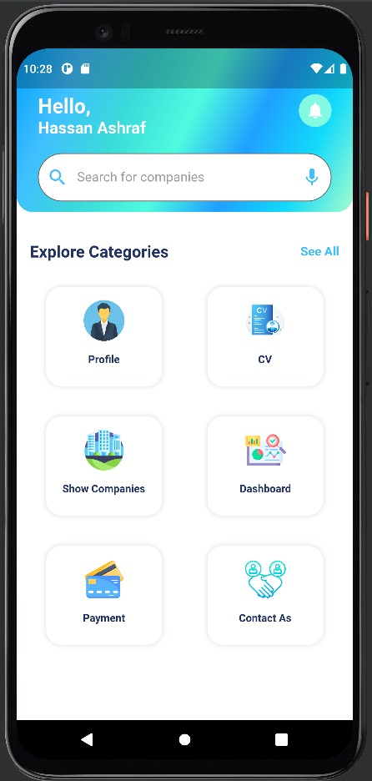

2.2 Non-Functional requirements:

* + 1. Performance:
* Response Time:
  + The system should respond to user actions within a maximum of 2 seconds.
* Scalability:
  + The application should be able to handle a scalable number of simultaneous users, especially during peak times.
    1. Usability:
* User Interface Design:
  + The user interface should be intuitive and user-friendly, adhering to industry design standards.
* Accessibility:
  + The application should comply with accessibility standards (e.g., WCAG) to ensure it is usable by people with disabilities.
    1. Reliability:
* Availability:
  + The system should aim for 99.9% uptime, allowing for scheduled maintenance.
* Fault Tolerance:
  + The application should be designed to handle system failures gracefully without losing critical data.
    1. Security:
* Authentication and Authorization:
  + Implement secure authentication mechanisms and ensure proper authorization for different user roles.
* Data Privacy:
  + Adhere to data protection regulations and ensure the privacy of user information.
    1. Scalability:

Database Scalability:

* The database should be scalable to handle a growing amount of user and job data.
* Consider implementing database sharding or clustering as needed.
  + 1. Compatibility:
* Browser Compatibility:
  + Ensure compatibility with major web browsers (e.g., Chrome, Firefox, Safari, Edge).
* Device Compatibility:
  + The application should be accessible and functional across various devices and screen sizes.
    1. Maintainability:
* Code Maintainability:
  + Code should be well-documented and follow best coding practices for ease of maintenance.
* Modularity:
  + Design the application in a modular way to facilitate updates and modifications.
    1. Performance Monitoring and Logging:
* Monitoring:
  + Implement tools for monitoring application performance and user interactions.
* Logging:
  + Maintain logs for system activities, errors, and user interactions for troubleshooting and auditing purposes.

2.3 Technology:

1. Database:

* For our database we will be using Mongo db to store our user’s data.

1. Back end:

* We will use NodeJS, Express for our backend.
* NodeJS is an event driven backend environment with the ability of adding limitless nodes which allows for extremely high vertical or horizontal scalability,
* It is well known for its performance and speed, as well as giving the option for cross-platform development.
* While Express is one of the most powerful node frameworks available, it's easily integral into the Node environment and makes the development much easier.

1. Front-end:

* Our front-end will utilize Flutter.
* Flutter allows for cross platform development on iOS, android and web

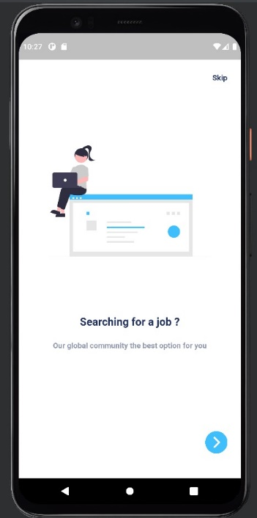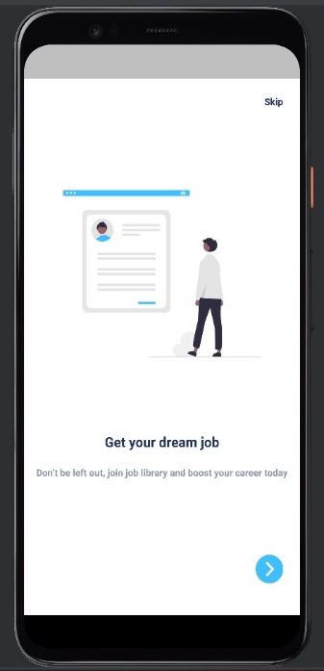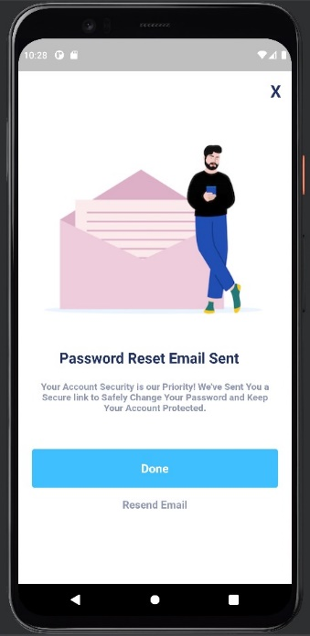2.4: System application:

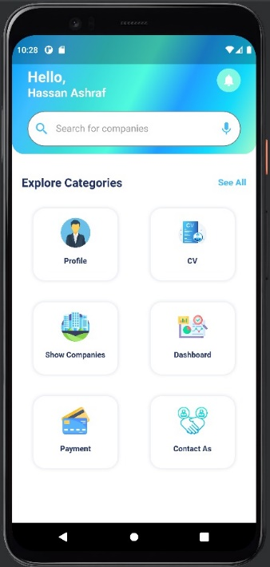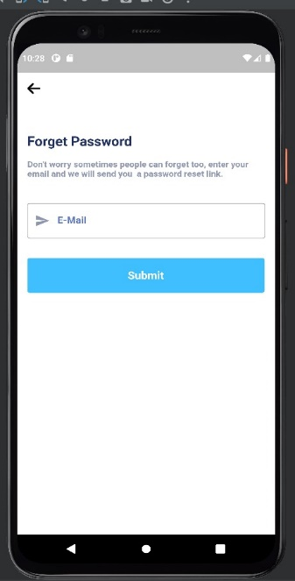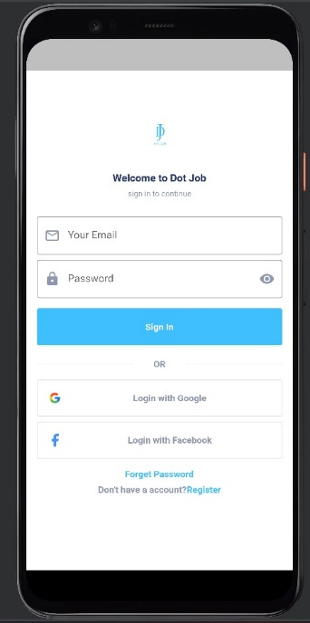

Figure 7: Home Page

Figure 6: verification Page

Figure 5: Login Page

Figure 4: Start Page

Figure 3: Welcome Page

Figure 2: Introduction Page